SQL Queries in a Hadoop Cluster (HiveQL)

**Data Preparation**

1. Add files to Hadoop Cluster (Linux)

hadoop fs -put /root/lab/station_data.csv /user/lab/station_dat.csv

hadoop fs -put /root/lab/trip_data.csv /user/lab/trip_dat.csv

2. Create database (SQL)

create database bikes;

use bikes;

4. Create Tables

create table bikes.stationtemp (

station_id int, name string, lat float, lon float, dockcount int, landmark string, install string)

row format delimited

fields terminated by ',';

load data inpath '/user/lab/station_dat'

overwrite into table bikes.stationtemp;

create table bikes.station as

select station_id, name, lat, lon, dockcount, landmark,

from_unixtime(unix_timestamp(install , 'M/d/yyyy')) as install_date

from bikes.stationtemp;

5. Test if bikes.station exists, then drop temporary table.

select * from bikes.station limit 5;

drop table bikes.stationtemp;

create table bikes.triptemp (

trip_id int, duration float, start_date string, start_station string, start_terminal int, end_date string, end_station string, end_terminal int, bike_number int, sub_type string, zip int)

row format delimited

fields terminated by ',';

load data inpath '/user/lab/trip_dat.csv'

overwrite into table bikes.triptemp;

create table bikes.trip as

select trip_id, duration, from_unixtime(unix_timestamp(start_date , 'M/d/yyyy H:m')) as start_date, start_station, start_terminal, from_unixtime(unix_timestamp(end_date , 'M/d/yyyy H:m')) as end_date, end_station, end_terminal, bike_number, sub_type, zip

from bikes.triptemp;

6. Test if bikes.trip exists, then drop temp table.

select * from bikes.trip limit 5;

drop table bikes.triptemp;

Find the 'most popular' bike (the bike that has made the highest number of trips)

select bike_number, count(*) as ct from bikes.trip group by bike_number order by ct desc limit 1;

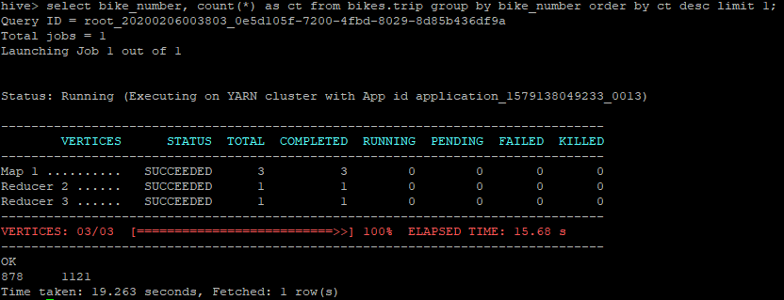

Find the number of trips made by each subscription type

select count(bike_number), sub_type from bikes.trip group by sub_type;

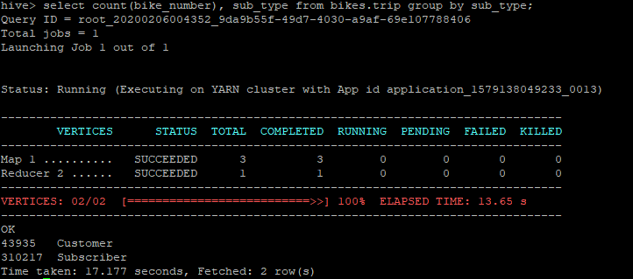

Build a table that shows which stations are connected, and the minimum duration between them.

create table bikes.stationlist as select

t.start_terminal, t.end_terminal,

min(unix_timestamp(t.end_date) - unix_timestamp(t.start_date)) as min_duration

from bikes.trip t

group by start_terminal, end_terminal;

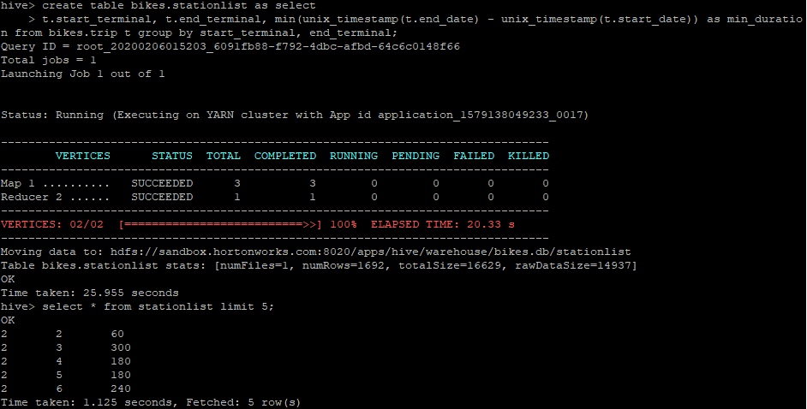

4. Find the number of trips originating from each landmark.

select s.landmark, count(t.trip_id) from bikes.station s, bikes.trip t

where s.station_id = t.start_terminal group by s.landmark

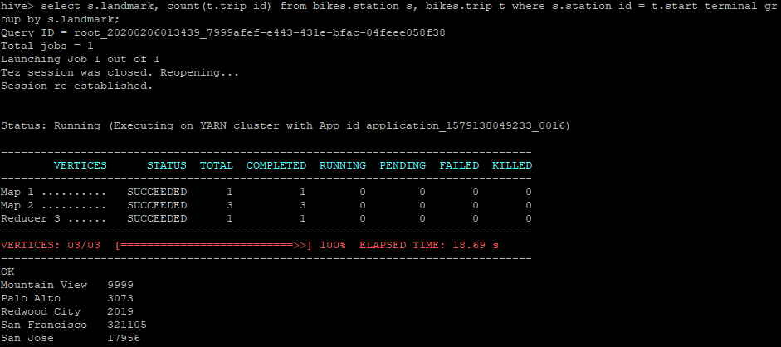

Find the number of trips crossing landmarks.

select s.landmark as strt_landmark, send.landmark as end_landmark, count(t.trip_id) as ct

from bikes.trip t join bikes.station s on s.station_id = t.start_terminal join bikes.station send

on send.station_id = t.end_terminal where s.landmark <> send.landmark

group by s.landmark, send.landmark;

